5E Lesson Plan Template
Teacher | Jared Bryant Faulk
Subject area/course/grade level | US History I: Beginnings to 1877.
Standards (State and ISTE Standards for Students) | SS10.US1.1.4 - Explaining triangular trade and the development of slavery in the colonies  SS10.US1.2 - Compare regional differences among early New England, Middle, and Southern colonies regarding economics, geography, culture, government, and American Indian relations. [A.1.a., A.1.b., A.1.d., A.1.g., A.1.i.]
Objectives | - Students will be able to explain how the system of triangular trade functioned and analyze its role in the growth of slavery in the American colonies. (SS10.US1.1.4)  - Students will compare and contrast the economic, geographic, cultural, and governmental characteristics of the New England, Middle, and Southern colonies, identifying how these differences shaped colonial development. (SS10.US1.2)  - Students will be able to create a digital infographic using Canva that illustrates the triangular trade system and highlights regional differences among the New England, Middle, and Southern colonies, including their economies, cultures, governments. As well as create a brochure from a colony of the students’ choice where they will use what they have learned about each colony to try and attract new settlers to their colony.
Differentiation Strategies: How will the lesson address the various learning styles of the students and the needs of those with special needs? | Visual- Instructional videos with captions, infographics, example works, and brochures.  Auditory- discussion questions, group collaboration.  Kinesthetic- hands on infographic and brochure creation through canva.  Special Needs/ELL; Peer-Partner Support, Extra Time, simplified templates.

The 5 Es
E | Description
Engagement | - Class Discussion: At the beginning of class students will be asked to draw their attention to the ViewSonic where this discussion question will be displayed:  The triangular trade connected Europe, Africa, and the Americas in a system that fueled wealth for some and suffering for others. At the same time, the New England, Middle, and Southern colonies were developing in very different ways. How did trade, slavery, and regional differences shape colonial life and set the stage for the future of America?  Students will be organized into small groups and prompted to respond to this question, building off of each other’s answers. The teacher will walk around listening to the discussions and asking guiding questions such as: What role did enslaved Africans play in making this system work?  How did the demand for labor in the colonies connect directly to the growth of the slave trade?  How did the geography and climate of each region shape its economy?  Why did some colonies rely more heavily on enslaved labor than others?  In what ways do you think these regional differences might lead to future conflicts in the colonies?  - QUIZ TIME: After the completion of the discussion students will be prompted to open google classroom on their chrome books where they will find a short quiz on the information they have already learned about triangular trade.  https://www.proprofs.com/quiz-school/story.php?title=3dq-what-do-you-know-about-the-triangular-tradeew
Engagement Assessment | Students will be assessed in the engagement section by their involvement and responses during the group discussion period as well as by the scores achieved during the Quiz on Triangular Trade.
Exploration | - Digital Postcard: Students will then be prompted to open Canva in preparation for the next portion of the lesson. Students will use a postcard template of their choice to create a digital postcard from one of the three regions of the Colonies. Students will need to include the following information:  - Choose a Region  - Select one colonial region: New England, Middle, or Southern.  - Write your postcard from the perspective of a colonist living there.  - Write Your Message (4–5 sentences minimum)  In your postcard message, you must describe:  - Economy: What kind of jobs or resources are common in your colony? (e.g., shipbuilding, farming, trading, plantations).  - Geography/Climate: What is the land and weather like? How does it affect farming or trade?  - Culture/Religion: What do people believe or value in your colony? Are there religious groups, traditions, or cultural differences?  - Government: How are decisions made in your colony? Is there self-rule, assemblies, or wealthy leaders in charge?  - Write as if you are “sending a letter” home to a friend or family member in England. Be creative while still using accurate details.  Example sentence starters:  - “Greetings from the New England Colonies! Life here is very different from back home…”  - “The climate here makes it possible to grow…”  - “Most of the people in my colony work as…”  - “Our government is run by…”  - Add a Visual  - Insert at least one image that represents your region. (Examples: a ship, wheat field, church, tobacco plant, colonial assembly hall).  - Make sure your image is relevant and appropriate.  - Design Your Postcard  - Use a neat layout (space for the message + space for the image).  - Keep your font readable and professional.  - Add a creative “postcard-style” title such as “Greetings from the Southern Colonies!”  Student Led Research Gallery:  - Get into small groups (2–3 students).  - Each group will be assigned one research topic from the list below.  - Use your Chromebooks to gather at least 3–4 accurate facts about your topic.  - Wikipedia is NOT a credible source.  - Create a One-Slide Visual using Google Slides.  Your slide should include:  - The name of your topic (as the slide title).  - 3–4 bulleted facts (in your own words).  - 1 relevant image (map, ship, goods, person, etc.).  - A short “Why these matter” statement (1 sentence explaining why your topic was important to the triangular trade).  - Gallery Walk.  - Once slides are complete, we’ll put them together into a class slideshow.  - We will do a digital gallery walk rotate through slides, take notes, and be ready to answer questions.  - Look for patterns (e.g., how trade goods connected regions, who benefitted, who suffered).  - Student groups will be assigned one of the following words to complete their portion.  • Triangular Trade  • Middle Passage  • Slavery  • Molasses  • Rum  • Sugar  • Tobacco  • Ships  • Textiles  • Plantations  Link to the work sample google slides presentation for the gallery walk review is under the explanation section.  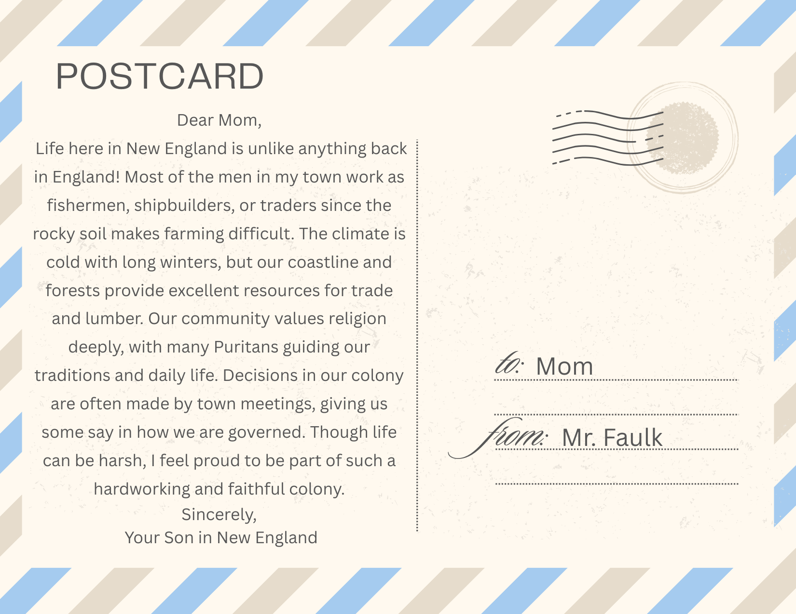  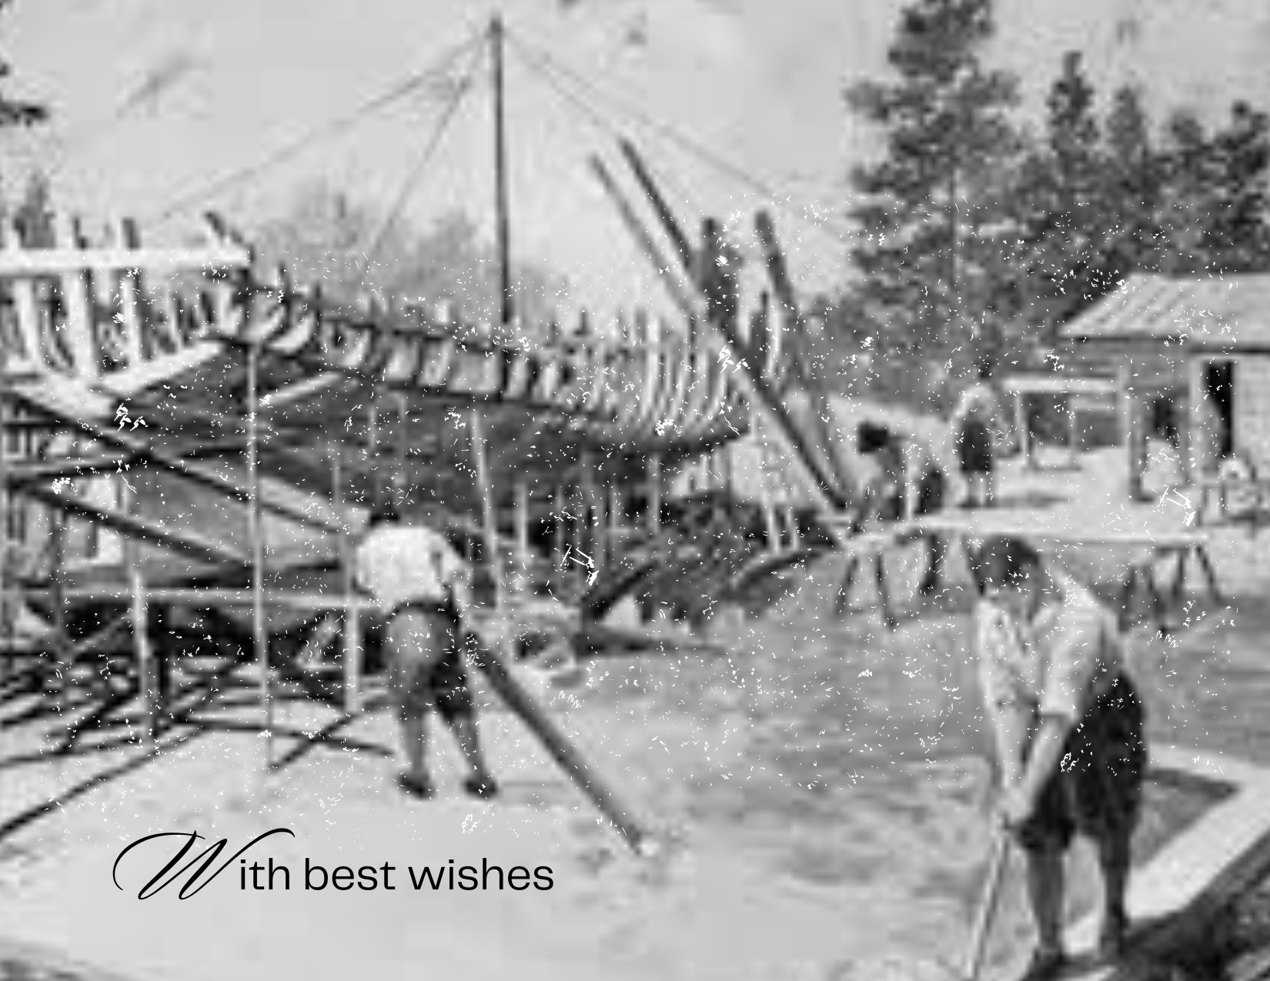
Exploration Assessment | Students will be assessed in two ways during the Exploration period. For the Digital Postcard activity students will be assessed based on the following rubric.  Colonial Regions Digital Postcard Rubric (10 pts)  For the Gallery Walk portion of this section students will be assessed by the teacher as he walks around while students are creating their slides. They will also be assessed during the explanation section when the Teacher uses the Gallery Walk to clear up misconceptions with subject content.
  Category | 2 pts (Strong) | 1 pt (Partial) | 0 pts (Needs Work)
  Content Accuracy | Includes accurate details about economy, geography, culture, and government. | Includes some details but 1 area is missing or inaccurate. | Missing most details or mostly inaccurate.
  Perspective/Creativity | Clearly written from a colonist’s perspective with creativity. | Some attempt at perspective or creativity but not consistent. | No perspective or creativity shown.
  Completeness | Postcard has 4–5+ complete sentences and fully answers the prompt. | Postcard has 2–3 sentences OR is missing part of the prompt. | Postcard has fewer than 2 sentences OR is incomplete.
  Visual/Design | Includes 1+ relevant image; postcards are neat and easy to read. | Includes an image but it’s only somewhat relevant OR postcard is cluttered. | No image OR postcard is messy and unreadable.
  Mechanics | Few to no grammar/spelling errors; writing is clear. | Some errors that distract but meaning is still clear. | Frequent errors make writing hard to understand.
Explanation | Research Gallery Walk review: Teacher will use the Google slide Presentation made by the students to explain the importance of each item and their respective role in triangular trade and the growth of the colonies. Students will take notes and be prompted to answer questions throughout.  GOOGLE SLIDES LINK  - https://docs.google.com/presentation/d/1eB9z-vSdhMPKb61EM6Rb5B9vHSLMEZEprJvDPPYQapk/edit?usp=sharing  This is not the actual PowerPoint created by the kids, this is an example for them to gain understanding about the assignment.  Higher Order Thinking Questions:  - What does the treatment of enslaved Africans during the Middle Passage tell us about how people in power viewed them?  - How did plantations depend on triangular trade to survive and grow?  - What does the triangular trade reveal about the connections between economic growth and human suffering, and how does this history continue to affect us today?
Elaboration | Triangular Trade and the Colonies Infographic: Students will be tasked with taking all of the information they knew as well as what they have learned today in order to create a one-page infographic that displays the regional differences in the colonies as well as highlights the main goods and takeaways used in triangular trade.  Instructions:  - Triangular Trade (Left Side)  - Draw or insert a triangle to represent the trade routes.  - Label each side:  - Europe → Africa: Manufactured goods (guns, textiles)  - Africa → Americas: Enslaved Africans (Middle Passage)  - Americas → Europe: Raw materials (sugar, tobacco, cotton)  - Add at least 1–2 small icons/pictures (ship, barrel, crops, chains, etc.)  - Colonial Regions (Center/Right Side)  Make a 3-column chart with the headings: New England, Middle, Southern.  For each region, include these details:  - Economy (what jobs/products made money)  - Geography (climate and land)  - Culture/Government (religion, government style, way of life)  Tip: Use short phrases or bullets instead of long sentences.  - Add at least one picture/icon per region (like wheat for Middle Colonies, ship for New England, tobacco leaf for Southern Colonies).  - Reflection (Bottom)  - Add a box titled: “Key Takeaways”  - Write 2–3 sentences answering this question:  “How did triangular trade contribute to the growth of slavery, and how did regional differences shape colonial life?”  Design Guidelines  - Use clear fonts (one bold for titles, one simple for text).  - Color code each region:  - Blue = New England  - Green = Middle  - Gold = Southern  - Keep the layout neat and easy to read.  Colonial Recruitment Brochure: Students will be assigned to groups and allowed to select one of the 13 original Colonies. Students will be prompted to work together on Canva to create a one-page brochure with the goal of attracting new settlers to their colony.  Instructions:  - Get Your Group & Colony  - Form a group of 3–4 students.  - Students will be allowed to select a colony: New England, Middle, or Southern.  - Research Key Information  Find details about your colony that will attract settlers:  - Economy: Main crops, industries, and trade opportunities  - Government: Type of local government, laws, or freedoms  - Environment: Climate, geography, natural resources  - Culture & Society: Religion, traditions, population diversity, relations with American Indians  Tip: Look for interesting facts to make your colony sound exciting!  - Plan Your Brochure  - Decide what to include in each section.  - Make your brochure persuasive and appealing:  - Catchy title or slogan  - Short, clear paragraphs  - Fun facts or “Did You Know?” boxes  - Images, maps, or icons  - Create Your Brochure  - Use Canva to design a one-page brochure.  - Include all four categories (economy, government, environment, culture).  - Make it visually interesting and easy to read.  - Share & Reflect  - Email your presentation to the teacher and include all group member names in the body of the email.  - Discuss:  - What makes your colony appealing?  - How do geography, economy, and culture influence settlement?  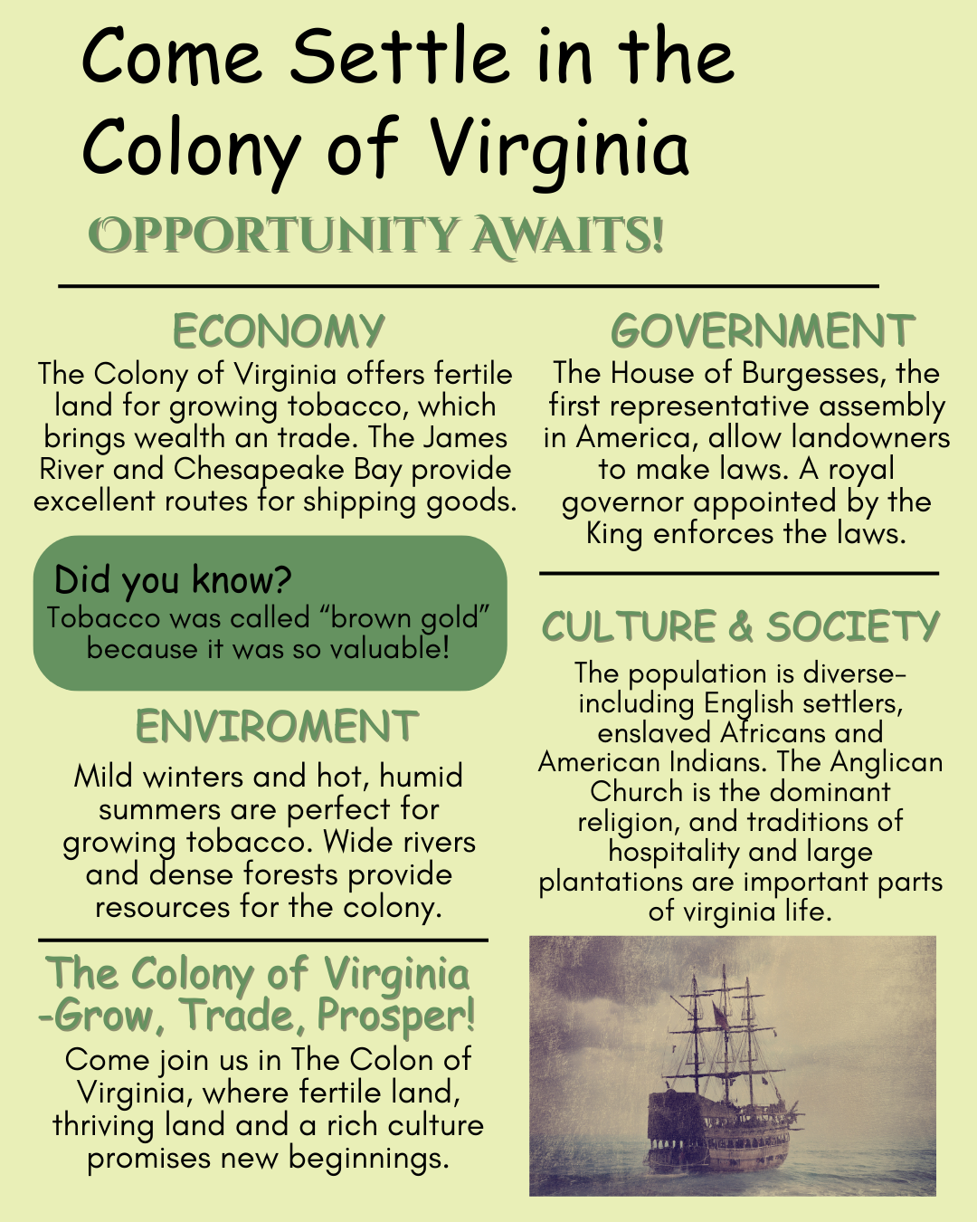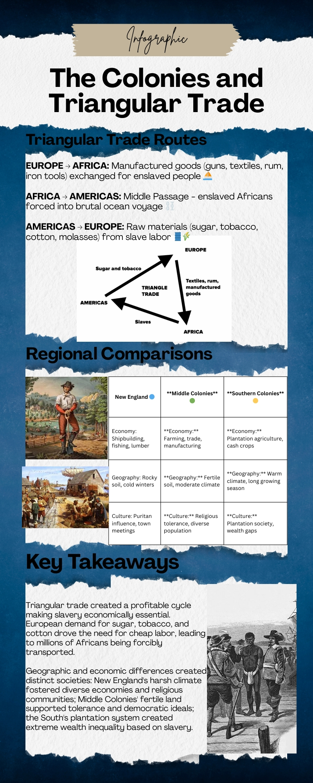
Evaluation | - Rubrics:  Colonial Brochure Grading Rubric (10 Points Total)  - Total Score: ____ / 10  - Rubric:  Colonial Life & Trade Infographic (10 pts)
  - Category | - 4 – Excellent | - 2 – Needs Improvement | - 1 – Minimal / Missing
  - Historical Accuracy (3 pts) | - All information is accurate and detailed | - Some facts inaccurate or incomplete | - Mostly inaccurate or missing
  - Persuasiveness (2 pts) | - Very persuasive; strongly encourages settlers | - Minimal persuasive language | - Not persuasive
  - Organization & Clarity (2 pts) | - Well-organized, very clear | - Somewhat disorganized; hard to follow | - Disorganized; confusing
  - Creativity & Visual Appeal (2 pts) | - Excellent visuals; very creative | - Minimal visuals; little creativity | - No visuals; not visually appealing
  - Collaboration (1 pt) | - All members contributed equally | - Unequal contribution; some inactive | - One or two did all work
  - Category | - 2 pts (Strong) | - 1 pt (Partial) | - 0 pts (Needs Work)
  - Triangular Trade Diagram | - Accurate triangle with labels and 2+ relevant images/icons. | - Triangle shown but missing 1 label or 1 image/icon. | - Diagram incomplete or inaccurate.
  - Colonial Regions Content | - Each region includes economy, geography, and culture/government details with 1+ image. | - Regions missing 1–2 details or images. | - Regions missing most details or images.
  - Reflection | - 2–3 complete sentences; clearly explains slavery and regional differences. | - 1–2 sentences; addresses only one part of the question. | - Missing or incomplete response.
  - Design & Organization | - Neat, easy to read, color-coded regions, creative visuals. | - Somewhat organized; missing 1 design element (colors, neatness, readability). | - Messy, hard to follow, little effort in design.
  - Mechanics | - No/few grammar or spelling errors; writing is clear. | - Some errors but writing is understandable. | - Frequent errors make writing hard to understand.
Evaluation Assessment | Replace this description with your work. Add a description of how you will assess this phase and any required assessment created.

